**Voltz Rematch**

Editor's Note: Anything that says “idle” should just have a single frame from their idle animation respectively. Glasses idle is obvious. When “CROWD” is speaking, use the default psych engine dialogue boxes.

**Heavyswing:**

1.Voltz: Alright, I've summoned you two back here because I've got a score to settle.



2. Boyfriend: beep?



3. Voltz: Do you seriously not remember me? We've been through this before!



4. Boyfriend: …



5. Boyfriend: Pico?



6. Voltz: SON OF A BI-



**Fizz:**

1. Voltz: Alright! Not too shabby if I do say so myself!



1. Boyfriend: Pretty impressive, seems like you actually managed to improve!



1. Voltz: Well, you learn a thing or two when you become outright homeless for a few months.



1. Boyfriend: Context?



1. Voltz: Nope!



**Homestretch**

1.Boyfriend: Nice job dude, now you're actually on my level!



2. Voltz: That's what you think, I'm about to embarass you in front of this whole crowd!



3. Boyfriend: What makes you think that?



4. Voltz (glassesidle): Reused punchline :)

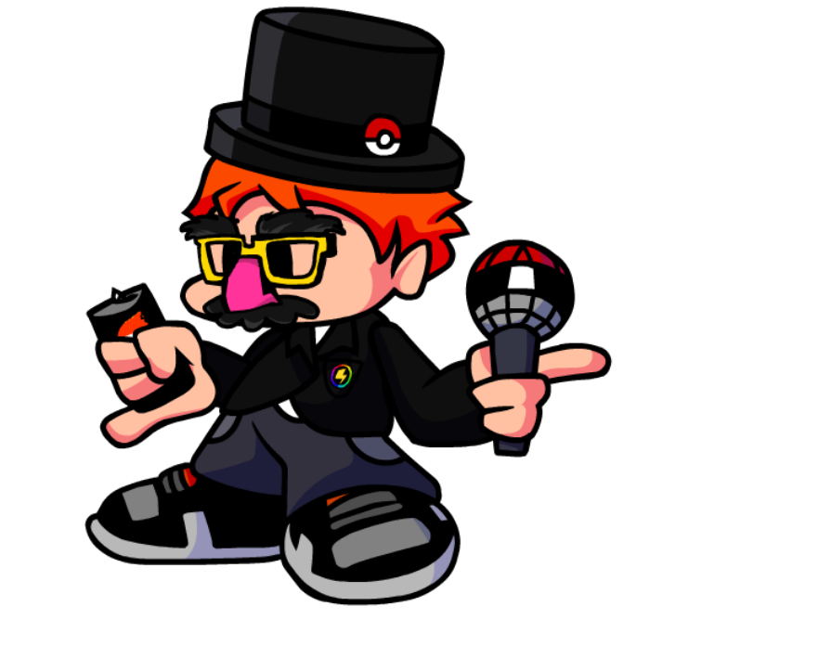

5. Boyfriend (glassesidle): epic plot device moment

